Trip To Brazil
From | To | Connection | Departure | Arrival
Dublin | Sao Paulo - Brazil | Amsterdam | 22/01/2021 | 12/02/2021
Dublin | Sao Paulo - Brazil | Amsterdam | 28/01/2022 | 14/02/2022
Dublin | Sao Paulo - Brazil | Lisbon | 08/02/2023 | 26/03/2023
Notes: all the above trips purpose was to visit my family as they leave in Brazil and
which I tend to go once a year.

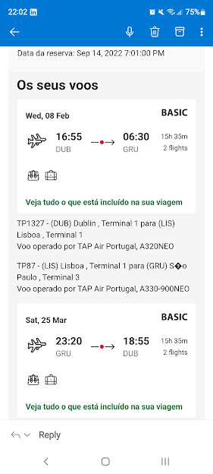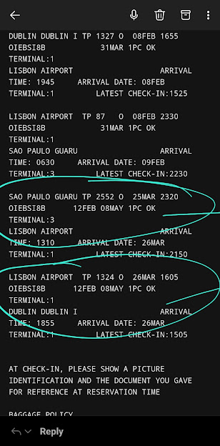

Bruna Ferreira De Azevedo Carvalho
01 The Court - Larch Hill Dublin - D17PW19
brunaferreirac@hotmail.com / 083 398 8741
24th July 2023
EU Treaty Rights Division,
Immigration Service Delivery, Department of Justice, 13/14 Burgh Quay, Dublin 2, D02 XK70
Statement of Relationship for Bruna Carvalho and Rafael Alvarenga
To Whom It May Concern,
I am writing this letter in support of the relationship between myself, Bruna Carvalho, and my husband, Rafael Henrique De Mello Alvarenga. I kindly request that you consider this statement as part of our application.
I first had the pleasure of meeting Rafael in Brazil during January 2021 trip. At that time, I was visiting the country for holidays and family visit. Through mutual acquaintances, we were introduced, and our initial encounter marked the beginning of a profound connection that would eventually lead to our romantic involvement.
The foundation of our relationship was established in August of the same year, when we began to communicate more frequently, fostering a deep emotional bond. Our shared values, interests, and aspirations have continued to strengthen our commitment to one another, and we have since embarked on a journey of mutual support, understanding, and growth.
Throughout our relationship, we have made significant efforts to nurture our connection. Frequent video calls, messages, and virtual interactions have played a vital role in bridging the gap and allowing us to sustain a meaningful and committed partnership.
As our relationship continues to flourish, we were both eager to take the next step and consolidate our commitment by residing together in Dublin/Ireland. Our shared dream of building a life together, supporting one another's ambitions, and contributing positively to our respective communities drives us forward with unwavering determination.
I humbly request that you consider the authenticity and sincerity of our relationship as demonstrated in this letter and the accompanying evidence. Our love and dedication to one another are genuine, and we are prepared to provide any additional information or documentation to substantiate our claim.
Thank you for your time and consideration. Please do not hesitate to contact me if further information is required.

Sincerely,
Bruna Carvalho ___________________________________________________________________
Rafael Alvarenga ___________________________________________________________________

